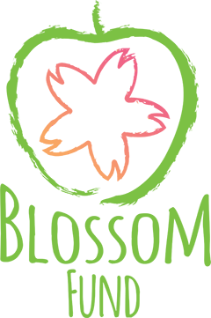

All applications must be submitted online using the online form.
The below are the questions in the online form that the applicant may like to prepare in advance of submitting the online application.
- Name of Organisation
- Address
- County
- Name of Applicant
- Position in the organisation
- Telephone
- Email
- Organisational Status (Note your organisation must be one of the following to apply for funding or your application will not be accepted)
  - Registered Charity with a CHY number OR
  - Not For Profit with a bank account and constitution- note you will be asked for proof of if shortlistedCHY Number
- Confirmation your organisation has been in existence for the last 12 months
- Name of Chief Executive
- Number of paid workers
- Number of voluntary workers
- Social Media Handles associated with your project/organisation?
- Describe your project in 100 words?
- How far is your nearest Applegreen from your project approximately?
- Why should Applegreen select your project/programme for funding? List three key achievements your organisation has in supporting disadvantaged children in your community (100 Words max)
- Name of project/programme which you are apply for funding?
- What is your project/programme and how does it support children under 12 years of age in your community? The focus on this fund is to support projects and programmes that support the health and well being of children living in disadvantaged circumstances. We want to support projects that promote either positive physical or mental health, healthy eating or other innovative ways of supporting children under this theme (200 Words Max)
- Is this a new or existing project/programme? Describe the need, problem and/or opportunity addressed by your project/programme in your community (150 words)
- Describe why your project needs a grant of €2,000. Please detail the impact this grant will have on the children your organisation supports (100 Words)
- How many children will benefit from the programme?
- If successful in receiving this grant in November when will the €2,000 grant be used?
- Give a breakdown of how the €2,000 will be spent.
- If the total cost of the project is greater than the amount you expect to receive from the fund, please indicate where the balance of the funds is expected to come from?
- Organisation's total expenditure in 2017
- Organisation’s total expenditure in 2018
- What was your organisation’s main source of income in 2018 and how much was this?
None of the data collected from these applications will be shared by Irish Youth Foundation or Applegreen for use outside this grant application. If the applicant wants to be updated about further grant applications from the Irish Youth Foundation they will have the opportunity to tick a box in the online form.

